**Chapter 1**

**Introduction**

Online Question paper submission is a web portal which is developed or implemented in ASP.NET domain or platform. This project is helpful for the Professor to submit the question paper to the examination cell or to the Examiner from this site. In current generation preparing the question paper and handovering in examination cell is not that much security. This project is developed for a Professor to maintain his details, experience, and preparation of question paper and submit the same to the examiner. The examiner also gives his information, experience and takes the approval from administrator and then selects the question paper. This project will work on the same line of online examinations; Apart from this it contains much more additional information such as: Course type, Department details and other details of professors and examiners in this web portal.

For the examination cell it is very difficult to identify whether the particular question paper is submitted or not. Online Question paper submission portal is implemented in 3 main modules. Professor module, Examiner module and Admin module. Admin module will add multiple courses and departments under different branches so Professor can easily know the best details of about subjects. Professor module ought to register with application and choose the course and upload the question paper to the site.

1. **Scope of the Project**

The scope of the project is used to manage the details of professor, Examiner and Administrator. The Professor and Examiners Sign up by providing the appropriate information and then take the approval from the administrator. According to course-wise Professors prepares the question papers and sends to the examiner, then examiner is selects the question paper and submits to the board. And all these records are stored in Online QPS Database.

**1.1 Main Modules of the Project**

**1.1.1 Administrator**

He administrates by giving approval to Examiner and Professor’s Signup. He also creates Course, Department, and Designation in order to fetch the correct and appropriate question paper for that course and department.

**1.1.2 Course Details**

It is created by the Admin and it consists of Details of specific course like: BCA, BBA, BCOM and more. The professor sends the Question paper on the basis of Course.

**1.1.3 Department Details**

It is created by the Admin and it consists of Details about the entire department which is created. The Department section consists of Department name and Address of that Department.

**1.1.4 Designation Details**

It is created by the Admin and it consists of Details about Designations of particular professor .This section consists of Designation name like Ass-professor, HOD and so on, it also has description section under Designation name which helps us to know of which particular department is the professor’s designation is from.

**1.1.5 Professor’s Signup**

In this section any professor can sign up. But the request is only approved by the Admin. This section consists of Login name, name of the professor, password and confirm password to confirm, phone number of that particular professor-main ID, and at last the address of that professor.

**1.1.6 Examiner’s Signup**

In this section any Examiner can sign up. But the request is only approved by the Admin. This section consists of Login name, name of the examiner, password and confirm password to confirm, and here it consists of designation and department where examiner can select any of the given designation and department. At last it asks for the Address and a photograph of that particular Examiner.

**1.1.7 Approval for both Professor & Examiner**

This action is performed by the Admin. He approves both professor and Examiner.

**1.1.8 Login for professor & Examiner**

A Professor who has been approved by the Admin can now Login in the Login section and same for the Examiner too.

**1.1.9 Details of Question paper**

Every Question Paper must be sent with appropriate details so as to know more about the paper at a single glance.

**1.1.10 View and Edit the Question Paper**

It is viewed and Edited by the Examiner and it is submitted to the University.

**1.1.11 Final Reports**

It creates and shows all the database records of this project.

**Chapter 2**

**Introduction to Front End and Back End Tools**

**2.0 Introduction to Microsoft Visual Studio 2010**

Microsoft released the .Net (pronounced dot net) Framework in March 2010. It’s biggest initiative since the launch of windows in 1991.Net is a revolutionary Multi language platform that knits various aspects of application development together with the Internet. The framework covers all layers of software development above the operating system. Several software will be developed by Microsoft to achieve this goal. It is accepted that every player in the industry, be it a software developer or a device manufacture, adopt .Net so that they can be integrated. The .Net initiative is all about enabling data transfer between networks, PCs and devices seamlessly, independent of the platforms, architecture and solutions. Microsoft has taken many of the best ideas in the industry combined in some ideas of their own, and bought them all in to one coherent package.Net is Microsoft’s next – generation platform for building web applications and web services. It is a platform for XML web services are of Microsoft.

.Net is Microsoft’s new internet and web strategy.

.Net is not a new operating system.

.Net is delivers software as web services.

.Net is a framework for universal services.

.Net is server centric computing model.

.Net is based on the newest web standards.

**2.1 The .Net Framework**

The .Net Framework includes classes, interfaces and value typed that help expedite and optimize the development process and give you access to system functionality. Microsoft designed C# from the ground up to take advantage of its new .Net Framework. The .Net Framework is made up of four parts, the Common Language Runtime, a set of class libraries, a set of programming languages, and the ASP.Net environment.

The .Net Framework was designed with three goals in mind. First, it was intended to make Windows applications much more reliable, while also providing an application with greater degree of security. Second, it was intended to simplify the development of Web applications and services that not only work in the traditional sense, but on mobile devices as well. Lastly, the framework was designed to provide a single set of libraries that would work with multiple languages.

**2.2 The Four Components of the .Net Framework**

**2.2.1 Common Language Runtime**

One of the design goals of .Net Framework was to unify the runtime engines so that all developers could work with a set of runtime services. The .Net Framework’s solution is called the Common Language Runtime (CLR) the CLR provides capabilities such as memory management, security, and robust error handling to any language that work with the .Net Framework. The CLR enables languages to inter operate with one another. Memory can be allocated by code written in only language and can be freed by code written in another language similarly, errors can be raised in one language and processed in another language.

**2.2.2 Net Framework Class Library**

The .Net Framework provides many classes that help developers’ re-used code. The.Net class Libraries contains code for programming topics such as threading, file I/O, database support, XML parsing, and data structures such as stacks and queues. This entire class library is available to any programming languages that support the .Net Framework. Because all languages now support the same runtime, they can re-use any class that works with the .Net Framework. This means that any functionality available to one language will also be available to any other .Net language.

**2.2.3 Net Programming Languages**

The .Net Framework provides a set of tools that help to build code that works with the .Net Framework. Microsoft provides a set of languages that are already .Net compatible.VB.Net is one of those languages.

**2.2.4 ASP.Net**

ASP.Net is unified web development platform that provides the services necessary to build enterprise-class Web applications. While ASP.Net is largely syntax compatible with Active Server Pages (ASP), it also provides a new programming model and infrastructure that allows creating a powerful new class of applications. ASP.Net is fully supported by the .Net Framework, allowing one to take full advantage of the Common Language Runtime (CLR), type safety, inheritance, and all of the other features of that platform.

ASP.Net is a compiled. NET-based environment; one can author applications in any .Net compatible language, including Visual Basic, C#, and J Scripts. Developers can easily access the benefits of these technologies, which include a managed Common Language Runtime environment, type safety, inheritance, and so on.

ASP.Net has been designed to work seamlessly with HTML editors and other programming tools, including Microsoft Visual Studio.Net. Not only does this make Web development easier, but it also provides all the benefits that these tools have to offer, including GUI that developers can use to drop server controls a Web page, as well as fully integrated debugging support.

**2.3 ASP.Net Web Forms**

Web Forms are in ASP.Net technology used to create programmable web pages. They can present information, using any mark-up language, to the user in any browser and used code on the server to implement application logic. That can contain rich verities of

**Standard form objects** like Textboxes, Panels, Tab strips, Combo boxes, Drop down list boxes, Place Holder, Check boxes, File Up loader, multiple views, Radio Buttons, Image Button, Image, Image Map...

**Form Data Objects** like Access, SQL, Entity, Object and XML Data sources, Grid View, Charts, Data list, Data pager, Query Extender, Repeater...

**AJAX Extensions** like Script Manager, Timer, Update Panel...

**HTML Form Objects** like Input Button, Input Text, Input Reset, Input File, Input Submit, Input Password, Input Radio, Input Checkbox, Text Area, Image, and Div...

**Navigational Objects like** Menu, Site Map Path, Tree View...

That provides a convenient way of interaction to the end user with the website and enriches the graphical aspects of the webpage...!

**2.4 Introduction to SQL SERVER 2010**

The Microsoft SQL Server 2010 database has been selected as the database of choice of the Internet Information Server (IIS) and Active Server Pages (ASP). When we store data in SQL Server we store data in tables. Tables in turn are stored in databases. Finally databases are stored in database devices. When we install SQL Server it creates a master database device. The master database device contains all the system databases used internally by SQL Server such as the master and temp databases for our use we can create database device and database of our own.

A database device is the allocation of disk space for use by a database and its contents and its contents (tables, indexes, stored procedures, triggers and users) when we create a device SQL Server asks for the amount of disk space we want to reserve for that device. More than one database can reside in a device. When we create a new database, SQL Server asks for the name of the device in which to create the database, as well as the size of the database.

**2.5 Features of SQL Server**

Microsoft SQL Server supports a full set of features that result in the following benefits.

**2.5.1 Ease of use**

SQL includes a set of administrative and development tools that improve our ability to install, deploy, manage and use SQL Server across several sites.

**2.5.2 Scalability**

The same database engine can be used across platforms ranging from laptop computers running Microsoft Windows 95 to very large; Multiprocessor servers running Microsoft Windows NT, Enterprise Edition and Ultimate Edition.

**2.5.3 Ease in building data warehouses**

SQL Server includes tools for extracting and analyzing summary data for online analytical processing (OLAP).

SQL Server also includes tools for visually designing databases and analyzing data using English based questions.

**2.6 SQL API (SQL Application Programming Interface)**

Embedded SQL applications use the DB-Library DLL to access SQL server. The SQL Server ODBC driver users do not access Microsoft SAL Server directly. They use an application written to access the data in SQL Server. SQL Server can also be accessed through COM, Microsoft ActiveX, or Windows DNA (Windows Distributed Internet Applications Architecture) components. Applications are written to access SQL Server through a database Application Programming Interface (API).

**Chapter 3**

**Requirement Specifications**

**3.0 Introduction**

The **Software requirement specification** provides a complete description of **Online Question Paper Submission** and specification of thetype of question paper selected by examiners. The expected professors of this document are to provide the online registration for the examiner and assure a specialized and interactive means of maintaining and monitoring.

**3.1 Scope**

The Online Question Paper Submission is designed to run on the server and allows users to register, create a new database entry and update an existing database entry. The database will be held in an SQL database on the server.

**3.2 Hardware Requirement**

Processor : Intel Core Duo 2.0 GHz or more

RAM : 1 GB or More

Hard disk : 80GB or more

Monitor : 15” CRT or LED monitor

Keyboard : STANDARD

Mouse : STANDARD

**3.3 Software Requirement**

Operating System : Microsoft Windows 7/8

Front End Tool : ASP**.**NET 2010

Back End Tool : Microsoft SQL Server 2010

**3.4 System Study**

**3.4.1 Initial study**

This involves the investigation of the existing system which is time consuming with the user and is insufficient depth. This also includes the collection and study of detailed information and literature regarding the complete existing procedure.

The detailed initial study properly documented and the falling and problems are noted separately. The System is properly designed and proper outline of the proposed computerized system is prepared. The proposed design is brought against all the known facts and further proposals are made. Various resources including the software, hardware and manpower requirements are decided and are mentioned in the report.

**3.4.2 User objectives**

**User Requirements Specifications**

Actual user community participation and their requirements analysis is a key to success of any new information system. To carry out this work, identification of users who will actually use the system is foremost. Users at every level were even an opportunity to define their goals, objectives and their respective information needs. In addition to this exercise a critical through investigation of present reports and query generated, were carried out to define any other additional requirements that can be useful to the others.

The findings of users and other related exercise to access particular user needs are summarized below concisely:

* The system must provide a graphical user interface.
* Redundancy must be reduced at the maximum level.
* Discrepancies should be avoided.
* Security systems must be provided.

**3.4.3 Feasibility Study**

The prime focus of the feasibility study is evaluating the practicality of the proposed system keeping in mind a number of factors.

The following factors are taken into account before deciding in favor for the new system:

**3.4.3.1 Economic Feasibility**

The Proposed Resume Tracking System will save lots of paper work and Facilitate magnetic record keeping thereby reducing the costs incurred on above heads. This reduction in cost prompts the company to go for such computer-based system.

**3.4.3.2 Technical Feasibility**

As the Saying goes, “to err is human”, Keeping in view the above fact, bow-a-days all organizations are automating the repetitive and monotonous works done by humans. The key process areas of current system are nicely amenable to automation and hence the technical feasibility is proved beyond doubt.

**3.4.3.3 Operational Feasibility**

The day to day maintenance of the Resume details is error prone and time-consuming. The computerization will not only increase the operational efficiency of the staff.

**3.4.3.4 Time and Resource Feasibility**

This system helps the user to find in the best usage of resources keeping in track of all the resume details over a period of time, thereby reducing the decision.

A Blue print for the development and analysis of the ONLINE QPS.

**3.5 System Design**

System design provides the understandings and procedural details necessary for implementing the system recommended in the system study. Emphasis is on the translating the performance requirements into design specifications. The design phase is a transition from a user-oriented document (System proposal) to a document oriented to the programmers or database personnel.

System design goes through two phases of development:

* Logical Design
* Physical Design

A data flow diagram shows the logical flow of the system. For a system it describes the input (source), output (destination), database (data stores) and procedures (data flows) all in a format that meets the user’s requirement. When analysis prepares the logical system design, they specify the user needs at a level of detail that virtually determines the information flow into an out of the system and the required data resources. The logical design also specifies input forms and screen layouts.

The activities following logical design are the procedure followed in the physical design e.g., producing programs, software, file and a working system. Design specifications instruct the user about what the system should do.

**3.5.1 Logical and Output Design**

The logical design of an information system is analogous to an engineering blue print of an automobile. It shows the major features and how they are related to one another. The detailed specification for the new system was drawn on the bases of user’s requirement data. The outputs inputs and databases are designed in this phase.

Output design is one of the most important features of the information system. When the output is not of good quality the users will be averse to use the newly designed system and may not use the system. There are many types output, all of which can be either highly useful or can be critical to the users, depending on the manner and degree to which they are used.

Outputs from computer system are required primarily to communicate the results of processing to user; they are also used to provide a permanent hard copy of these results for later consultation various types of outputs required can be listed as below:

* External outputs, whose destination is outside the organization
* Internal outputs, whose destination is with the organization.
* Operational outputs, whose use is purely within the computer department e.g., program-listing etc.

Interactive outputs which involve the user is communicating directly with the computer. It is particularly important to consider human factor when designing computer outputs. End user must find outputs easy to use and useful to their jobs, without quality output, user may find the entire system unnecessary and avoid using it. The term “output” in any information system may apply to either printer or displayed information. During the deigning the output for this system, it was taken into consideration, whether the information to be presented in the form of query of report or to create documents etc.

**3.6 Other important factors that were taken into consideration are:**

* The End user, who will use the output.
* The actual usage of the planned information
* The information that is necessary for presentation
* When and how often output and their format are needed. While designing output for project based Attendance Compilation System, the following Aspects of output designing were taken into consideration.
* The outputs (i.e., well formatted table outputs in the screen itself) design header simple to read and interpret.
* Format of each output was another important point taken into consideration. Output media, for each output appropriate media is decided whether it will be displayed on screen or will be taken to printer or both.
* Other output design related specifications, i.e., how frequently the outputs will be generated, how many pages or sheets approximately it will keep up, what is its planned use and output distribution to user are also taken into account.

These were a few major designing issues, which were taken into consideration, while deciding the output specifications for the system. As direct beneficiary of reports is the user community, they were consulted constantly at every level. Formats and screen design for various reports were identified, taking into account the user requirements. Before finalizing these were given to users for any improvement and suggestions. End users issues taken into consideration were Readability, Relevance and Acceptability.

Once all the output reports to be generated by system were identified they were given to users for their acceptance. For prototyping various outputs, final outputs models were created with dummy data, before they were finalized.

**3.7 Input Design**

The input design is the link that ties the information system into the user’s world. Input specifications describe the manner in which data enters the system for processing. Input design features can ensure the reliability of the system and produce results from accurate data, or they can result in the production of erroneous information.

**3.7.1 Objectives of input design**

**Five objectives of design input focus on**

* Controlling the amount of input required
* Avoid delay
* Avoiding errors in data
* Avoiding extra steps
* Keeping the process simple.

Input stages several activities have to carry out as part of the overall input process. They include some or all of the following:

Data recording (i.e., collection of data)

Data encapsulation (i.e., transfer of data)

Data conversion (i.e., controlling the flow of data)

Data validation (i.e., checking the input data)

Data correction (i.e., correcting the errors)

**Input designs are aimed at reducing the chances of mistakes of errors**. As the human beings are prone to errors there is always a possibility of occurrence of chance of errors. Adequate validation checks are incorporated to ensure error free data storage. Some of the data validation checks applied is as following:

Redundancy of data is checked. It means the records of primary key do not occur twice. Primary key field of any table must not be left blank. Whenever items are coded, input code is checked for its, validly with respect to several checks. Utmost care has been taken to incorporate the validation at each stage of the system.

Ex: When entering records into employee information table for employee, it is checked that whether the corresponding employee exists in the employee information table etc.

Enough messages and dialogue boxes are provided while design screen, which does guide user at the time of any errors, or at time of entry. This feature provides a user-friendly interface to native users. It can be emphasized that input designs of the system is so designed that it ensures easy and error free data entry mechanism. Once one is sure of input data the output formatting becomes a routine work.

**Chapter 4**

**Coding Snippet**

**Admin Login**

Imports System.Data.SqlClient

Partial Class Account_Default

Inherits System.Web.UI.Page

Public con As New SqlConnection

Protected Sub Button1_Click(ByVal sender As Object, ByVal e As System.EventArgs) Handles Button1.Click

Dim cmd As New SqlCommand("select *from login where password='" & ADpass.Text & "'", con)

Dim rs As SqlDataReader

rs = cmd.ExecuteReader

If rs.HasRows = True Then

Response.Redirect("~/Admin/AdminHome.aspx")

Else

Response.Redirect("Alogin.aspx")

End If

End Sub

Protected Sub Page_Load(ByVal sender As Object, ByVal e As System.EventArgs) Handles Me.Load

con.ConnectionString = Application("str")

con.Open()

End Sub

End Class

**Client Registration**

Imports System.Data.SqlClient

Partial Class Account_ClientRegistration

Inherits System.Web.UI.Page

Public con As New SqlConnection

Public n As Integer

Protected Sub Page_Load(ByVal sender As Object, ByVal e As System.EventArgs) Handles Me.Load

con.ConnectionString = Application("str")

con.Open()

Dim cmd1 As New SqlCommand("select Max(UnId) from UniqueId", con)

Dim rs As SqlDataReader = cmd1.ExecuteReader

rs.Read()

n = rs(0) + 1

rs.Close()

End Sub

Protected Sub signup_Click(ByVal sender As Object, ByVal e As System.EventArgs) Handles signup.Click

If Empass.Text = EmCpass.Text Then

Label4.Visible = False

Dim cmd2 As New SqlCommand("select LogID from Client where LogID='" & LogName.Text & "'", con)

Dim rs As SqlDataReader = cmd2.ExecuteReader

rs.Read()

If rs.HasRows = False Then

rs.Close()

Dim cmd4 As New SqlCommand("insert into UniqueId(Unid,Type) values('" & n & "','Client')", con)

cmd4.ExecuteNonQuery()

Dim cmd3 As New SqlCommand("insert into Client values('" & n & "','" & LogName.Text & "','" & addr.Text & "','" & TextBox2.Text & "','" & TextBox1.Text & "','" & Empass.Text & "','Pending','" & emname.Text & "')", con)

cmd3.ExecuteNonQuery()

Response.Redirect("../Home.aspx")

Else

Label4.Visible = True

Label4.Text = "Choose Another Name"

LogName.Text = ""

LogName.Focus()

End If

Else

Label4.Visible = True

Label4.Text = "Re-Type Password"

End If

End Sub

End Class

**Chapter 5**

**Data Flow Diagram & ER Diagram**

**5.0 Design of Data Flow Diagram**

**DFD 5.0.1**

View & Edit Paper

Question Paper

Professor

Examiner

Course Details

Signup for Professor

Department Details

Signup for Examiner

**DFD 5.0.2**

Approval

**DFD 5.0.3**

Preparation & Submit

Verification

**5.1 ER Diagram**

**Chapter 6**

**Database Design and Tables**

**6.0 Admin Login Table**

|  |  |
| --- | --- |
| Column Name | Data Type |
| Username | Varchar(20) |
| Password | Varchar(20) |

**6.1 Professor Signup Table**

|  |  |
| --- | --- |
| Column Name | Data Type |
| Login Name | Varchar(50) |
| Professor Name | Varchar(50) |
| Password | Varchar(50) |
| Confirm Password | Varchar(50) |
| Phone Number | Number(10) |
| E-mail ID | Varchar(150) |
| Address | Varchar(150) |

**6.2 Examiner Signup Table**

|  |  |
| --- | --- |
| Column Name | Data Type |
| Login Name | Varchar(50) |
| Examiner Name | Varchar(50) |
| Password | Varchar(50) |
| Confirm Password | Varchar(50) |
| Designation | Varchar(50) |
| Department | Varchar(50) |
| Address | Varchar(50) |
| Photo | Varchar(150) |

**6.3 Professor Login Table**

|  |  |
| --- | --- |
| Column Name | Data Type |
| Professor ID | Varchar(50) |
| Password | Varchar(50) |

**6.4 Examiner Login Table**

|  |  |
| --- | --- |
| Column Name | Data Type |
| Examiner ID | Varchar(50) |
| Password | Varchar(50) |

**6.5 Create Department Table**

|  |  |
| --- | --- |
| Column Name | Data Type |
| Department Name | Varchar(50) |
| Address | Varchar(150) |

**6.6 Create Designation Table**

|  |  |
| --- | --- |
| Column Name | Data Type |
| Designation Table | Varchar(50) |
| Description | Varchar(150) |

**6.7 Create Course Name**

|  |  |
| --- | --- |
| Column Name | Data Type |
| Course Name | Varchar(50) |
| Description | Varchar(50) |

**6.8 Professor Approval Table**

|  |  |
| --- | --- |
| Column Name | Data Type |
| Professor ID | Number(4) |
| Professor Name | Varchar(50) |
| Address | Varchar(150) |
| Phone No | Number(10) |
| E-mail ID | Varchar(150) |

**6.9 Examiner Approval Table**

|  |  |
| --- | --- |
| Column Name | Data Type |
| Examiner ID | Number(4) |
| Examiner Name | Varchar(50) |
| Address | Varchar(150) |
| Designation | Varchar(50) |
| Department | Varchar(50) |
| DOR | Date() |

**6.10 Technology/Tool Selection**

The system should be developed using a web technology and should be developed as such that deployment of the system is east and effortless. Also the technology used should be as such that interactions for the customers are very easy and user friendly.

We had plenty of options to select the technology and tools. The selection criteria we set are as detailed below:

* The technology and upgrading the system very easy and less costly.
* The technology selected should be platform independent.
* The language should be easy and robust; making is simpler to learn for the new members.
* The application must be browser independent.

With all these details in mind, we selected ASP (Active Server Pages) as it stands out on all points mentioned above.

**6.11 Web Design Constraints:**

The following design constraints were kept in mind while designing the pages for the whole application.

The pages should be consistent and easy to operate. It should be designed in such a way that an average user who does not have much idea about ASP and related technology can still be able to access the information needed. The Navigation should be easy and stepwise.

**Chapter 7**

**I/O Screens**

**Screenshots of Online Documentation System**

**7.0 Home Page**



**7.1 Admin Login Page**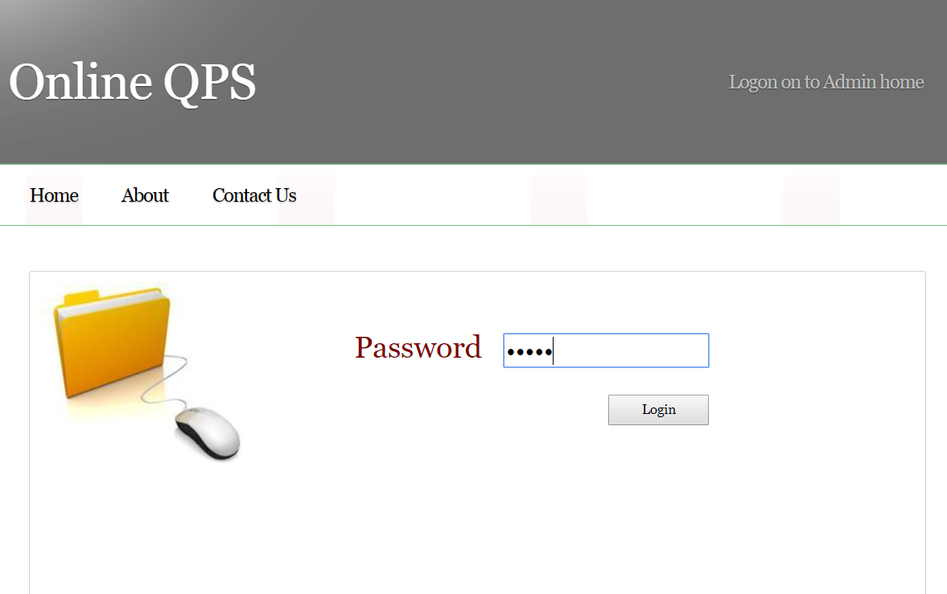

**7.2 Admin Main Screen Lists Section**

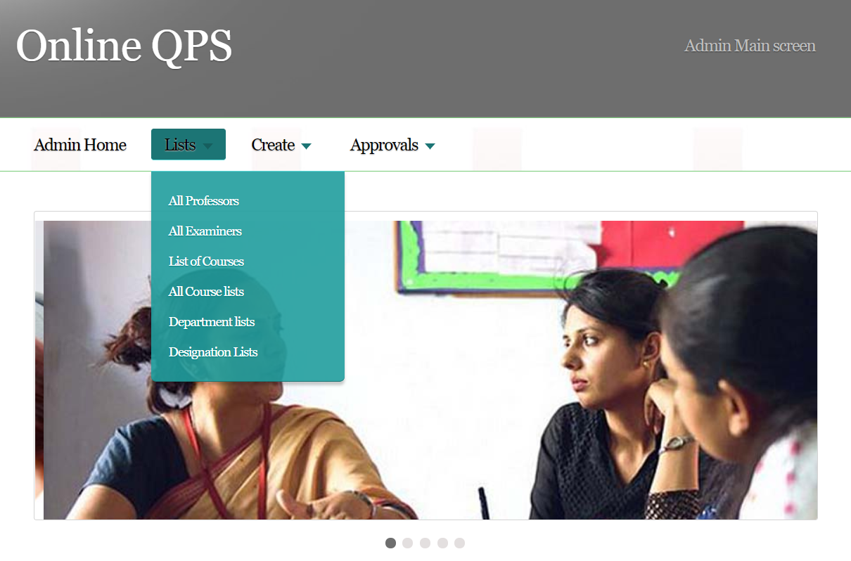

**7.3 Admin Main Screen Create Section**



**7.4 Admin Main Screen Approval Section**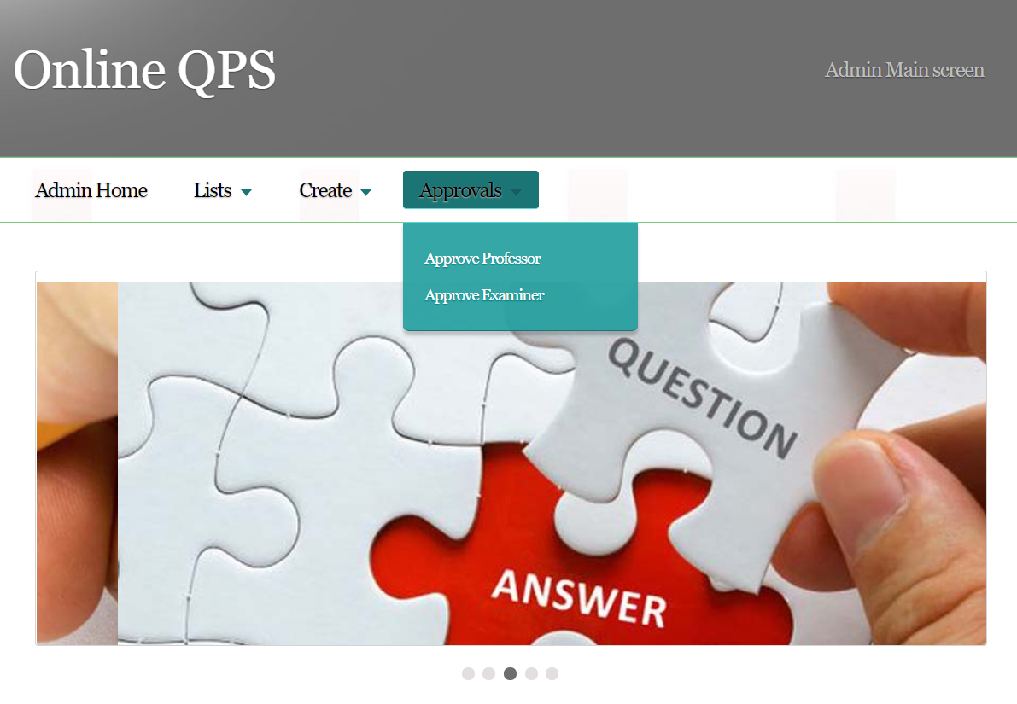

**7.5 Admin Department list**

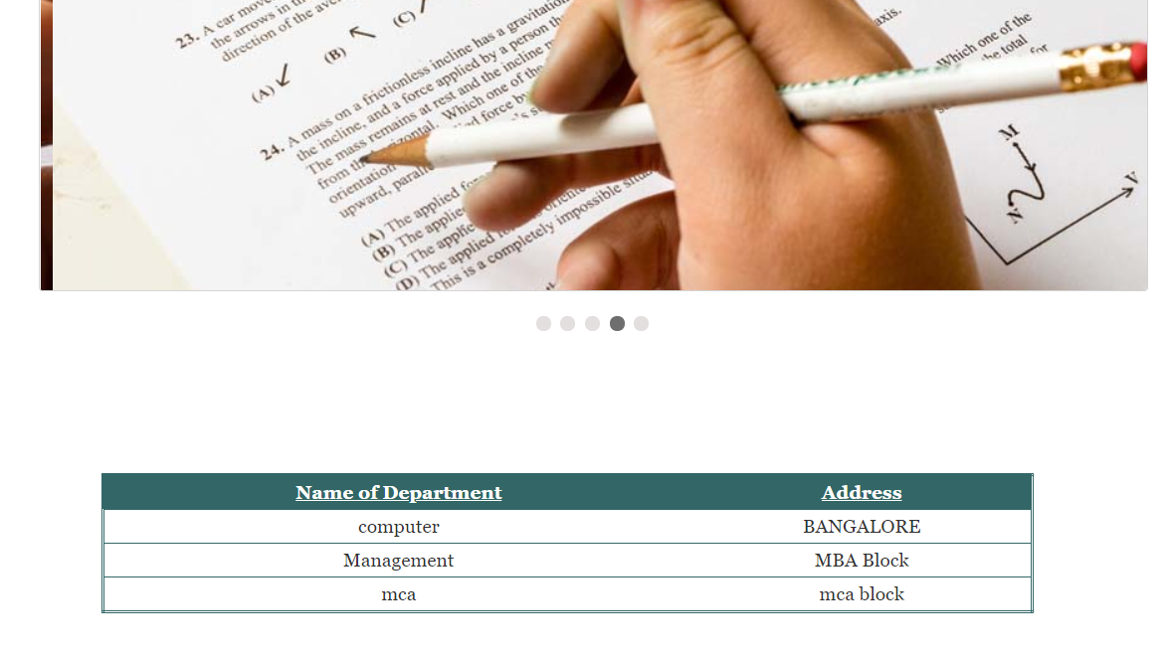

**7.6 Admin Designation List**

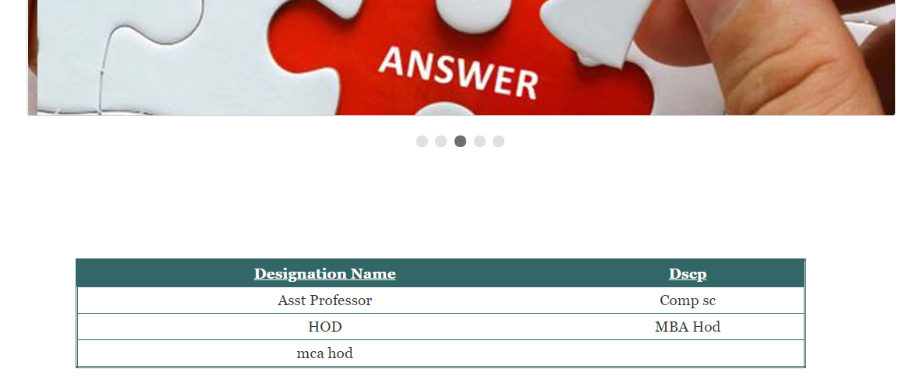

**7.7 Course Creation Section**



**7.8 Department Creation Section**

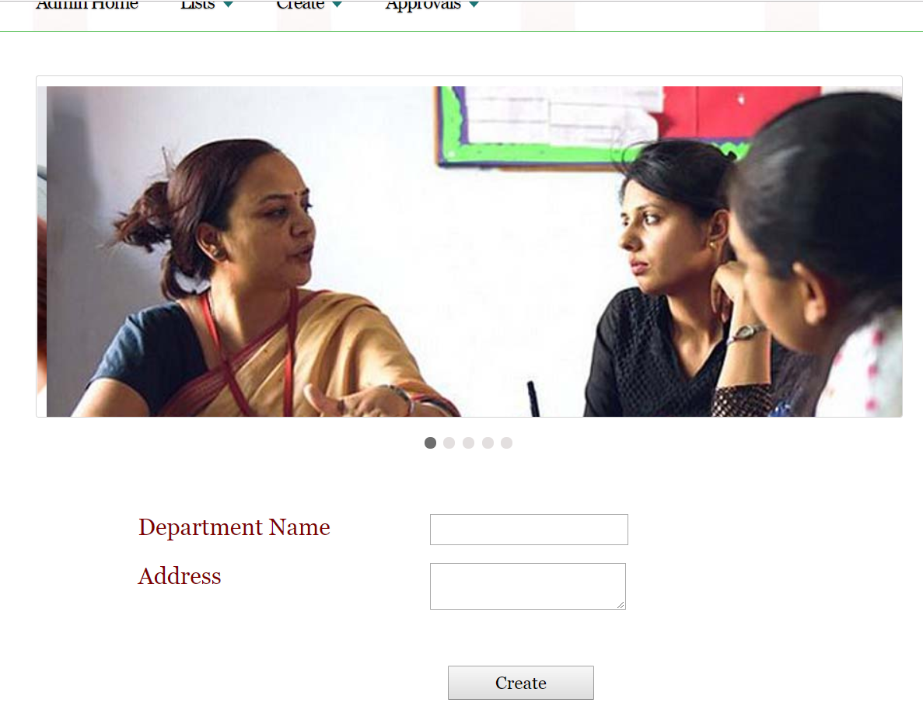

**7.9 Designation Creation Section**

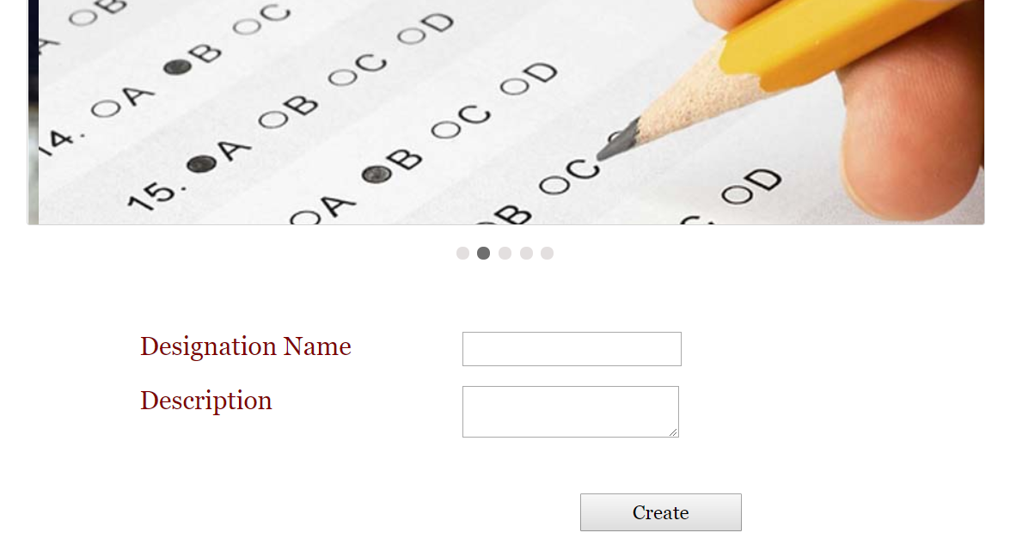

**7.10 Home Screen Signup Section**

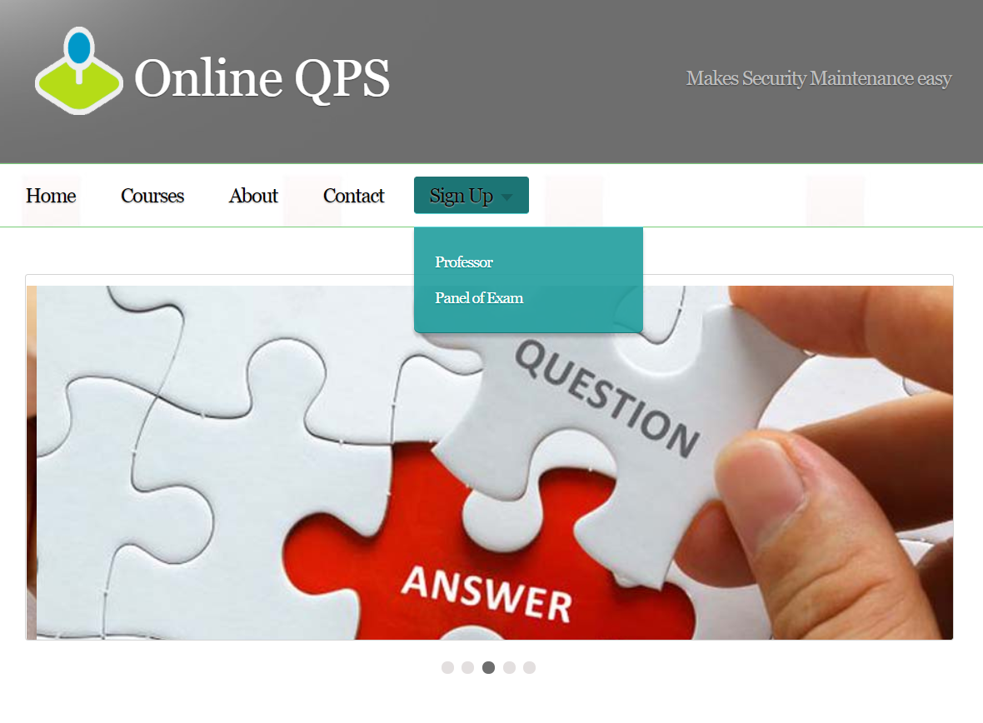

**7.11 Professor Signup**

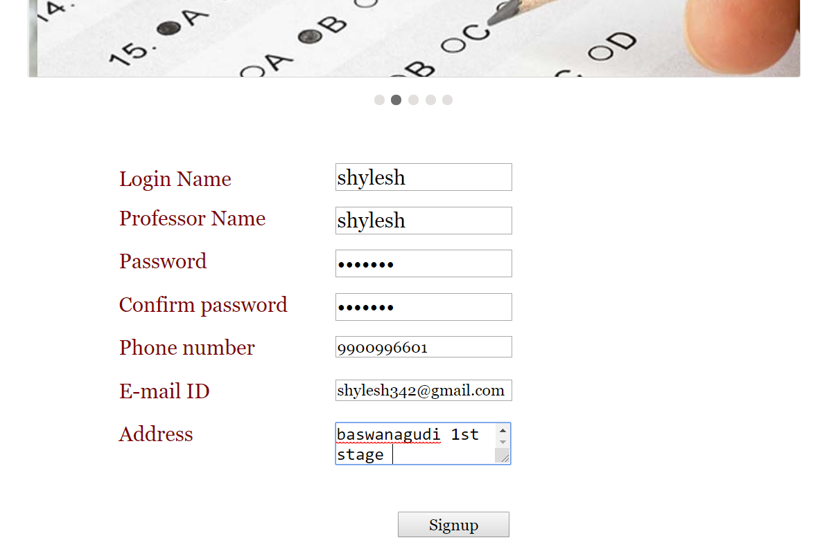

**7.12 Professor Approve Section**



**7.13 Professor Main Screen**



**7.14 Examiner Signup Section**

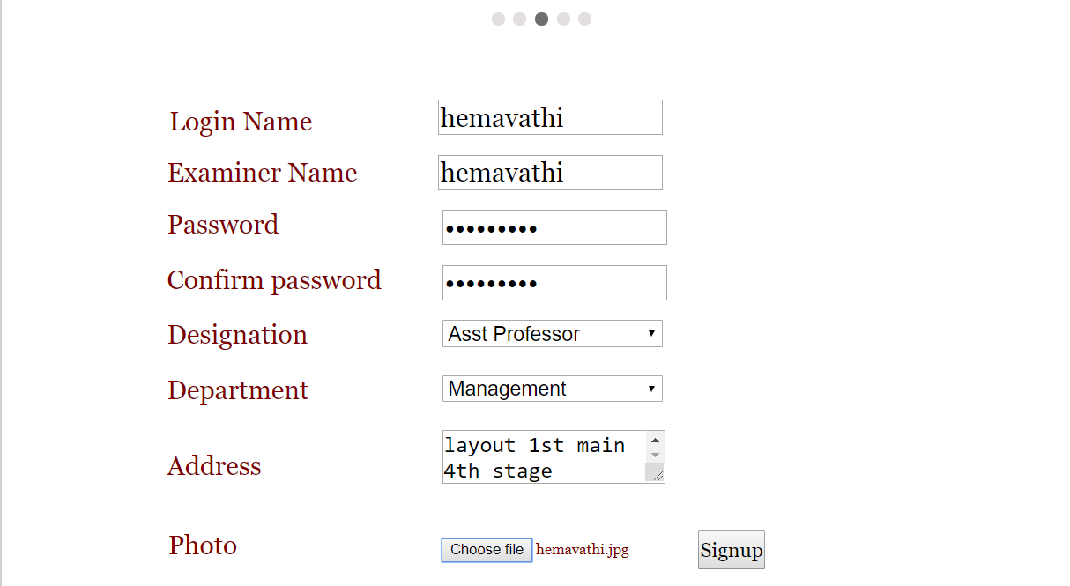

**7.15 Examiner Approve Screen**

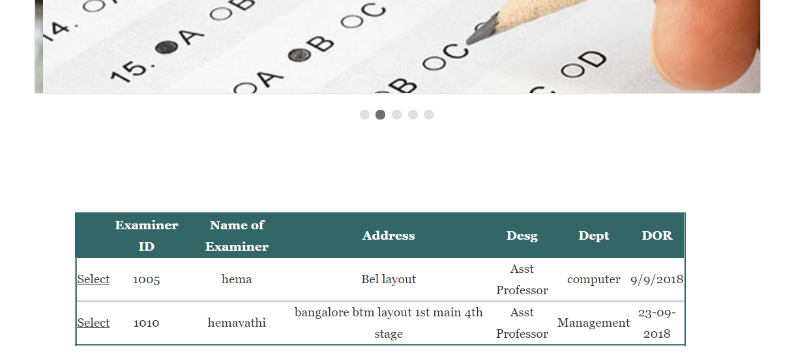

**7.16 Examiner Approve Page**

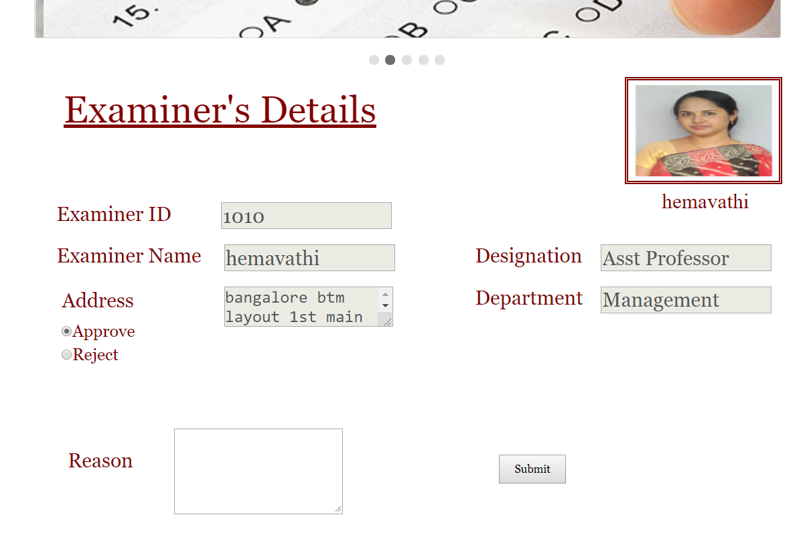

**7.17 User Login Page**

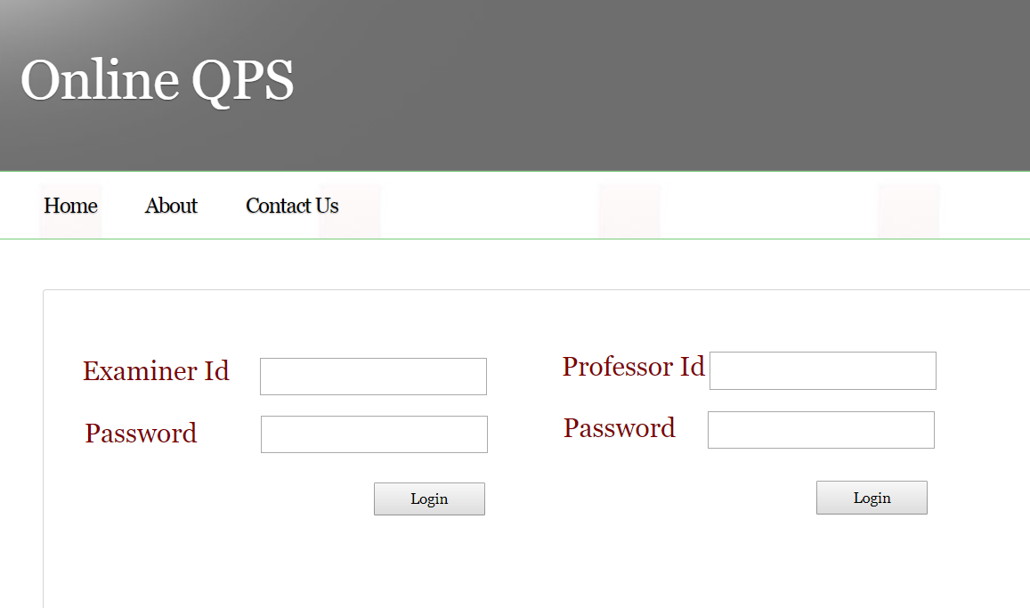

**7.18 Examiner Main Screen**

**7.19 Examiner Document Viewing Screen**

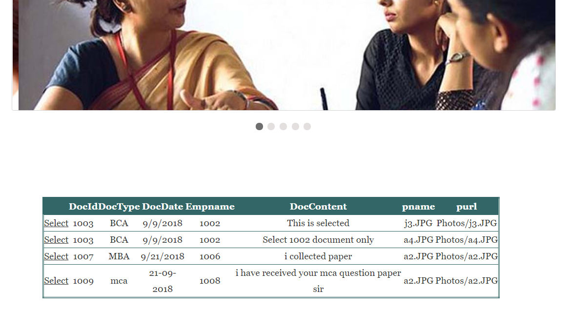

**7.20 Professor New Question Paper Screen**

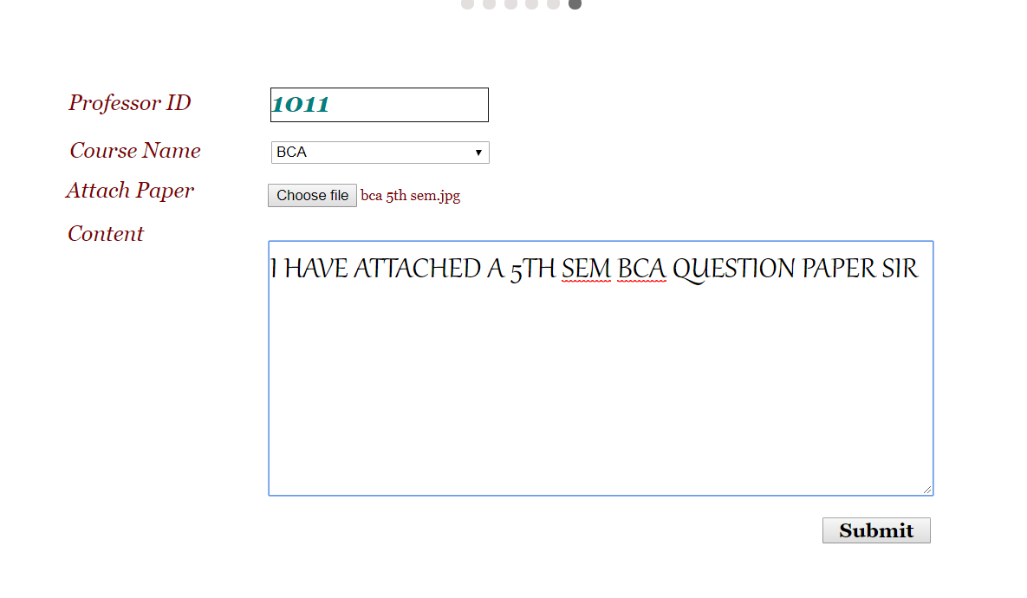

**7.21 Examiner Acknowledgment Screen**

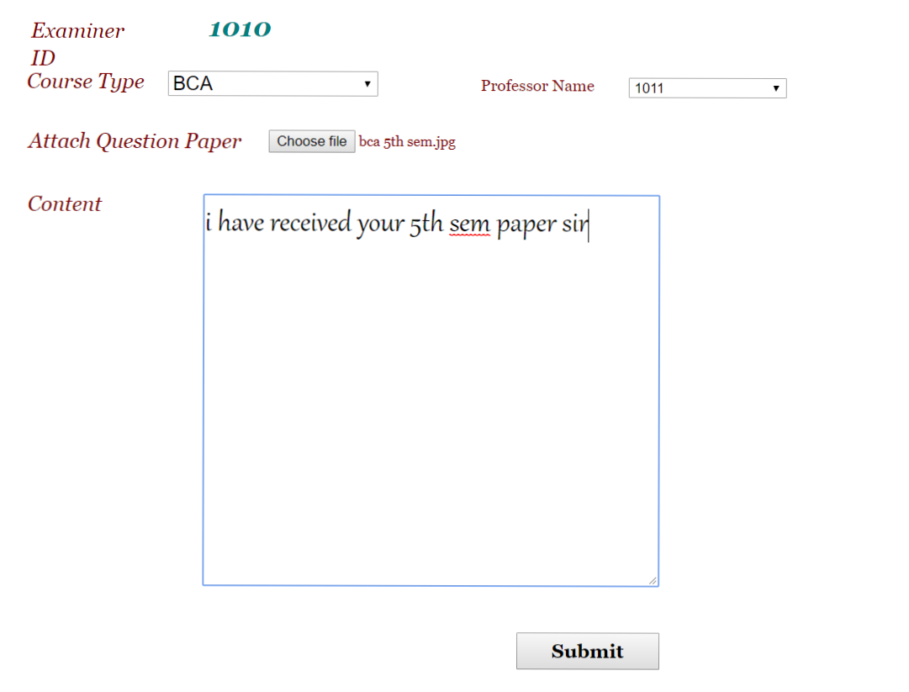

**Chapter 8**

**System Testing**

**8.0 Testing**

The development of software systems involves a series of production activities where opportunities for injections of human fallibilities are enormous. Errors may begin to occur at very inception of the process where the objectives, may be erroneously or imperfectly specified, as well as in later design and development stages. Because of human inability to perform and communicate in perfection, software development is accompanied by quality assurance activity.

Software testing is a critical element of software quality assurance and represents the Ultimate review of specification, design and coding. In general, testing starts with test plan. The test plan identifies all the testing related activities that need to be performed along with the scheduled and guidelines for testing. The plan also specifies the levels of testing that need to be done, by identifying the different testing units. Based on the plan, the testing commences. For each unit specified in the plan, first the test cases and reports are produced. Testing presents an Interesting anomaly for a software engineer.

**8.1 Testing is basically classified into**

* Black box Testing
* White box Testing

**8.1.1 Black Box Testing**

Black box testing focuses in the functional requirements of the software. It enables software engineer to derive sets of inputs conditions that will fully exercise all functional requirements for a program.

**Black Box testing attempts to find errors in the following categories**

* Incorrect or missing function
* Interface errors
* Errors in Data Structures or external Database access
* Performance errors
* Initialization and termination error

Generally Black box testing is applied for high level testing such as system testing, acceptance testing.

**8.1.2 White Box testing**

White Box testing, sometimes called glass box testing is a test case design method which uses the control structure of the procedural design to derive test cases.

**White Box testing is applied to**

* Exercise all logical decision on their true and false sides
* Exercise all loops at their boundaries and within their operational bounds
* Exercise internal data structures to assure their validity.

**8.2 Testing Strategies**

* Unit testing
* Integration testing
* Acceptance testing

**8.2.1 Unit testing**

Unit testing focuses on the verification effort on the smallest unit of software design module. Using the detailed design description as a guide, important control paths are tested to uncover errors within the boundary of the modules. The relative complexity of tests and the errors detected as a result is limited by constraint scope established for unit testing. The unit test is always white box oriented, and the step can be conducted in parallel for multiple modules.

**8.2.2 Integration testing**

With unit testing the modules may function properly, but at time they may have inadvertent, adverse affect on another; sub function, when combined, may not produce the desired major function; Individually acceptable imprecision may be magnified to unacceptable level; global data structures may present problems.

Integration testing is symmetric technique for constructing the program structure while at the same time conducting tests to uncover errors associated with interfacing. The objective is to take unit tested modules and build a program structure that has been dictated by the design.

**8.2.3 Acceptance Testing**

System under consideration is tested for acceptance by constantly keeping in touch with the prospective system. Series of acceptance test are conducted to enable the user to validate all requirements. Acceptance testing involves planning and execution of

**8.2.3.1 Functional Test**

Functional test is the exercising of the code with nominal input values for which the expected values for which the expected values are known.

**8.2.3.2 Performance Test**

Performance test determines the amount of execution time spent in various parts of the unit, program throughput and response time. This test is productive at the subsystem and system level.

**8.2.3.3 Stress Test**

Stress test is designed to intentionally break the unit and the strength and the limitation of the program are examined.

**Chapter 9**

**Conclusion**

It is believed that in the future Online QPS centralized document system with the concept of cloud technology will recede in importance as a strategic application to become a competitive necessity that must be adopted by most of the government departments.

India is striding smoothly towards integrated E-Governance. In next five years situation will be entirely different. Most of the companies are adopted cloud technology for maintenance of documents.

Online Question Paper Submission creates new trend in maintaining and verifying of documents through online and it reduces the work load.

**Chapter 10**

**Future Enhancements**

* News feed is essential for our day to day purpose; hence we will add a section about news. There, we are going to display the news about examination dates, deadline for submitting paper etc.
* We are going to add some more security to our system like OTP number for verification of the Professor’s and Examiner’s Phone number.
* Authentication of Professor and Examiner is also important, thereby uploading the College Approval Letter by Principal (Signed and Sealed), makes Admin easy to verify them.
* We will add few more Image File Format such as **TIFF, GIF, PNG, JPEG etc. in order to make Professor and Examiner upload photocopies easily.**
* To make a question paper, Professor has to be experienced; therefore we will add new section while signing up called Years of Experience. In that section professor has to enter how many years of experience he/she has in teaching profession.
* Live communication between Professor and Examiner makes easy to fix the problems; therefore we will add live messaging on portal.

**Chapter 11**

**Bibliography**

The references used during the course.

The following materials were used as the references during the course of the project.

**Text Books**

* *Dino Esposito, Programming Microsoft Asp.Net 4,  Microsoft Press 1 Edition (February 25, 2011)*
* *Powell ,Web Design: The Complete Reference 2ED, Tata McGraw-Hill 2nd Edition (August 27, 2003)*
* *Jeremy Shapiro, Visual Basic.Net: The Complete Reference 1st Edition, McGraw Higher Ed (September 24,2002)*

**Websites**

# *https://www.w3schools.com/asp*

# [*https://www.tutorialspoint.com/internet_technologies/website_designing*](https://www.tutorialspoint.com/internet_technologies/website_designing)

# *https://www.tutorialspoint.com/vb.net*